A MINI PROJECT REPORT ON
Retail Sales Performance and Profitability Analysis
Using Excel, SQL and Tableau
Submitted in partial fulfilment of the requirements for the subject
Data Analytics
Master of Computer Applications (MCA)
Submitted by
Harneet Kaur
MCA (AI/ML), 2025–2027
Roll No.: ____________
Submitted to
____________________ (Faculty Name)
Chandigarh University, Mohali, Punjab
Academic Session 2026–27

Table of Contents

(If page numbers are missing, right-click the table of contents in Word → Update Field → Update entire table.)

How to use this document
This single file contains everything about the project. Part A is the college report (sections 1–19 in the required format) – it can be submitted as it is after you fill in your roll number and faculty name. Part B is the implementation guide: every step that was performed, where each file is, and how you can repeat and verify each stage yourself. Part C is viva preparation: 35 questions with answers and a two-minute presentation script. Before submitting, you may delete Parts B and C from the copy you hand in, or keep them as appendices.
Honesty note (read this before the viva). All numbers in this report were calculated from the real dataset (Tableau "Sample – Superstore", 9,994 order lines). Nothing was invented. The MySQL database was built and checked on your own PC (MySQL 8.0.45): 9,993 order lines, 5,009 orders, 1,894 products, 793 customers, 296 returns, total sales $2,296,919.49, margin 12.47% and 299 loss-making products – exactly the expected values. The Tableau dashboards were built in Tableau Desktop 2026.2 on your PC; the screenshots in Section 14 are real exports from that workbook (04_Tableau\Retail_Sales_Dashboard.twbx). Open the workbook yourself and click through it before the viva so you can explain every part.

PART A – PROJECT REPORT

1. Abstract
Retail businesses record thousands of transactions, but raw transaction data does not by itself explain which products, regions or customer groups make money. This project analyses the Tableau "Sample – Superstore" dataset (9,994 order lines from a United States office-supplies retailer, January 2017 – December 2020) to measure sales performance and profitability. Microsoft Excel was used to inspect and clean the data and to build formula-based summaries and Pivot Tables; MySQL was used to store the data in a normalised relational database and to answer twelve business questions with SQL; Tableau Public is used to build an interactive dashboard.
After cleaning (one duplicate line removed, 11 missing postal codes filled, postal codes converted to text, repeated return records removed) the dataset contains 9,993 order lines, 5,009 orders and 793 customers. Total sales were $2,296,919.49 and total profit $286,409.08, an overall profit margin of 12.47% and an average order value of $458.56. Technology produced the highest sales and margin (17.40%), whereas Furniture generated 32.29% of sales but only 6.45% of profit (margin 2.49%). The West region led on both sales and profit; Central had the weakest margin (7.92%). Sales grew 51.5% from 2017 to 2020 with a strong September–December peak. Discount level showed a strong negative association with profitability: lines sold without discount earned a 29.51% margin, while every line discounted above 40% made a loss. Because the data is observational, this association is not presented as proof that discounts cause losses. The report closes with recommendations on discount control, the loss-making Tables, Bookcases and Supplies sub-categories, and the Central region.

2. Introduction
Data analytics is the process of collecting, cleaning, organising and examining data to find useful information that supports decisions. In retail, analytics answers everyday management questions: What are we selling? Where are we making or losing money? Which customers matter most? Are our promotions helping or hurting?
This mini project follows a complete, practical analytics workflow using three industry-standard tools taught in the Data Analytics subject: Microsoft Excel for data cleaning, formulas and Pivot Tables; MySQL for database design and SQL analysis; and Tableau Public for interactive visualisation and dashboards. The project deliberately avoids machine learning so that the focus remains on descriptive analysis (what happened) and diagnostic analysis (why it may have happened).

3. Problem Statement
A retail company sells office supplies, furniture and technology products to consumers, corporate clients and home offices across four US regions. Although total sales are growing, management does not have a clear, consolidated view of where profit is generated and where it is lost. In particular, management wants to know which categories, sub-categories, products, regions and customer segments perform well or poorly, how sales vary over time, and how discounting is associated with profit. The data exists only as a flat transaction file, so it must first be checked for quality problems, then organised and analysed, and finally presented in a form that non-technical managers can explore.

4. Objectives
- To inspect the Superstore dataset and identify genuine data-quality problems, distinguishing them from valid business values.
- To clean and prepare the data in Microsoft Excel using formulas, sorting, filtering and Pivot Tables.
- To design a normalised MySQL database with primary and foreign keys and load the cleaned data into it.
- To answer twelve defined business questions using SQL (aggregates, GROUP BY/HAVING, joins, subqueries, CASE and window functions).
- To calculate key performance indicators (KPIs): total sales, total profit, total orders, quantity, average order value, profit margin and growth.
- To build an interactive Tableau dashboard with KPI cards, trend, category, region and top-product views and filters.
- To interpret the results, state their limitations honestly and give realistic business recommendations.

5. Scope of the Project
In scope: the Orders, Returns and People sheets of the Sample – Superstore dataset (US only, 2017–2020); descriptive and diagnostic analysis of sales, profit, quantity, discount, region, category, sub-category, product, segment, time and returns; Excel, MySQL 8.0 and Tableau Public.
Out of scope: forecasting and machine-learning models, real company data, cost-of-goods and marketing-spend analysis (not available in the dataset), customer demographics, and causal experiments (e.g. A/B testing discount levels).

6. Business Questions
# | Business question | Answered in
1 | What are the total sales and total profit? | Excel KPI block, SQL Q1, Tableau KPI cards
2 | What is the total sales value for each product category? | Pivot, SQL Q2, Tableau
3 | Which regions generate the highest sales and profit? | Pivot, SQL Q3, Tableau
4 | Which products generate the highest profit? | SQL Q4
5 | Which products or sub-categories have negative profit? | SQL Q5a–Q5c
6 | How do sales change month by month? | Pivot (Year > Month), SQL Q6, Tableau line chart
7 | Which customer segments generate the most sales? | Pivot, SQL Q7, Tableau
8 | How are discounts associated with profitability? | Excel discount bands, SQL Q8, Tableau scatter
9 | What are the top 10 products by profit? | SQL Q9 (RANK), Tableau ranked bar
10 | Which categories have high sales but relatively low profitability? | SQL Q10a–Q10b
11 | What are the average order value and overall profit margin? | Excel KPIs, SQL Q11
12 | Which regions or categories perform below the overall average? | Excel "vs Avg", SQL Q12a–Q12b

7. Tools and Technologies
Tool | Version used / required | Purpose in this project
Microsoft Excel | Excel 2019 / Microsoft 365 (CONCAT needs 2019+) | Data inspection, cleaning, formula columns, SUMIF/COUNTIF summaries, Pivot Tables, charts
MySQL Community Server + MySQL Workbench | 8.0 (8.0.31+ for INTERSECT/EXCEPT) | Relational database, normalised schema, SQL analysis, views, indexes, access control
Tableau Desktop (Free Edition) / Tableau Public | 2026.2 used | Calculated fields, filters, context filters, interactive dashboards
Python (pandas) | 3.x – support only | Used only to independently cross-check totals and to draw reference charts. Not a primary tool.

8. Dataset Description
Source. "Sample – Superstore" is the standard practice dataset that Tableau ships with its products. The copy used here (Sample - Superstore.xls, 3.4 MB, sheets Orders, Returns and People) was taken from the public GitHub repository of the book *Mastering Tableau 2021* (PacktPublishing/Mastering-Tableau-2021, folder "Chapter 05"). The same dataset is also widely available on Kaggle (search "Superstore dataset"). Note that different copies use different year ranges (some 2014–2017, this one 2017–2020); the records are otherwise the same.
Nature of the data. It is a realistic but fictional training dataset. Each row of the Orders sheet is one product line within one order (an order with three different products has three rows).
Sheet | Rows × columns | Content
Orders | 9,994 × 21 | One row per order line
Returns | 800 × 2 | Order IDs that were returned (with many repeated rows)
People | 4 × 2 | Regional manager of each region

Column dictionary (Orders sheet)
Column | Type | Meaning / purpose | Example
Row ID | Integer | Unique line number (technical key) | 1
Order ID | Text | Order identifier; repeats for each line of the same order | CA-2019-152156
Order Date | Date | Date the order was placed – used for trends | 08-Nov-2019
Ship Date | Date | Date the order was shipped | 11-Nov-2019
Ship Mode | Text | Same Day, First Class, Second Class, Standard Class | Second Class
Customer ID | Text | Customer identifier | CG-12520
Customer Name | Text | Customer name | Claire Gute
Segment | Text | Consumer, Corporate or Home Office | Consumer
Country/Region | Text | Always "United States" (renamed to Country) | United States
City / State | Text | Delivery location | Henderson, Kentucky
Postal Code | Number in source | US ZIP code (should be text) | 42420
Region | Text | Central, East, South, West | South
Product ID | Text | Product code: category-subcategory-number | FUR-BO-10001798
Category | Text | Furniture, Office Supplies, Technology | Furniture
Sub-Category | Text | 17 sub-categories | Bookcases
Product Name | Text | Product description | Bush Somerset Collection Bookcase
Sales | Decimal | Revenue of the line after discount (USD) | 261.96
Quantity | Integer | Units sold in the line | 2
Discount | Decimal | Discount rate given (0 to 0.8 = 0% to 80%) | 0.00
Profit | Decimal | Profit of the line (negative = loss) | 41.9136

9. Methodology
The project followed a standard analytics life-cycle. Each stage was verified before the next one started (for example, totals after cleaning were compared with totals in MySQL and with an independent calculation).
Stage | What was done | Tool | Verification
1. Planning | Problem, objectives, scope, 12 business questions | — | Questions mapped to outputs (Section 6)
2. Data collection | Downloaded Sample – Superstore; kept the original file untouched | — | Row/column counts recorded
3. Data understanding | Checked rows, columns, data types, blanks, duplicates, labels, ranges | Excel | Data_Quality sheet
4. Data cleaning | Fixed genuine problems only (Section 10) | Excel | 9,993 rows; totals recalculated
5. Database & SQL | Normalised schema, load, 12 business queries | MySQL | Row counts and totals equal Excel
6. Analysis | KPIs, comparisons, trends, outliers, discount bands | Excel + SQL | Excel and SQL results agree
7. Visualisation | Worksheets and interactive dashboard | Tableau | KPI cards equal SQL Q1/Q11
8. Insights | Findings, recommendations, limitations | — | Every finding traced to a query or table

10. Data Cleaning
The guiding rule was: fix what is wrong or missing; never delete or change values that are unusual but true. A genuine data-quality problem is an error or gap in the data (a blank postal code, a duplicated row, a ZIP code that lost its leading zero). A valid business value can look extreme but is real (a loss of –$6,600 on a heavily discounted 3D printer, an 80% discount, a $22,638 single sale). Removing loss-making rows, for example, would hide exactly the problem the business needs to see.

10.1 Data-quality checks performed and their results
Check | Result in raw data | Genuine problem? | Action
Rows / columns | 9,994 / 21 | — | Recorded
Blank cells | 11 blank Postal Codes (all Burlington, Vermont); no other blanks | Yes | Filled with 05401, the ZIP code of Burlington, VT
Postal Code stored as a number | 438 ZIP codes below 10000 lost their leading zero (e.g. 2138 instead of 02138) – New England states | Yes | Converted to 5-character text with =TEXT(L2,"00000")
Exact duplicate rows (all columns except Row ID) | 1 pair: Row ID 3406 and 3407 (same order, product, sales, quantity, discount, profit) | Yes (treated as double entry) | Removed Row ID 3407 (impact: –$281.37 sales, +$12.06 profit)
Duplicate rows in Returns sheet | 800 rows but only 296 unique Order IDs | Yes | Removed duplicates → 296 rows
Spelling / label variants (Region, Category, Segment, Ship Mode) | None – each label appears in one form only | No | No change (checked with filters and COUNTIF)
Leading/trailing spaces | None | No | No change (checked with LEN vs TRIM)
Invalid numbers (Sales ≤ 0, Quantity ≤ 0, Discount < 0 or > 80%) | None | No | No change
Ship Date before Order Date | None | No | No change
Negative profit | 1,871 lines | No – valid business value | Kept and analysed
Product ID with more than one Product Name | 32 Product IDs | Source inconsistency | Not changed (correct name unknown); analysis by Product Name, SQL uses a surrogate key
Column name "Country/Region" | The "/" is awkward in SQL and Tableau | Minor | Renamed to "Country"

After cleaning, the Clean_Orders sheet has 9,993 rows. The removed duplicate is a judgement call: the two rows are identical in every field, which most likely indicates a double entry, but it is possible that the customer genuinely bought the same chair twice on two lines. The effect on all results is negligible (0.01% of sales), and the decision is documented in the workbook so it can be reversed.

10.2 Excel features applied
- Remove Duplicates, Filter, Sort (Data tab) – duplicates, blank detection, sorting by Order Date.
- Formatting – dates as dd-mmm-yyyy, Sales/Profit as currency with 2 decimals, Discount as %, Postal Code as text.
- Formula columns (14) – Order_Year (YEAR), Order_Month (TEXT), Ship_Days, Customer_Label (CONCAT), City_State (CONCATENATE), Profit_Margin (IFERROR), Profit_Status (nested IF), Discount_Band (3-level nested IF), High_Sales_Loss (IF+AND), Review_Flag (IF+OR), Price_Type (IF+NOT), Region_Manager (VLOOKUP+IFERROR), Returned (COUNTIF), Order_Count_Flag and Cat_Order_Flag (expanding COUNTIF/COUNTIFS for distinct order counts).
- Summary_Formulas sheet – KPIs with SUM, and summary tables by Category, Region, Segment, Discount Band, Year and Month using SUMIF, SUMIFS, COUNTIF and AVERAGEIF, with an IF/AVERAGE "Below Avg / Above Avg" flag.
- Pivot_Tables sheet – eight Pivot Tables on one worksheet (Category, Region, Segment, Discount Band, Sub-Category within Category, Year × Category, Region × Category profit, Year > Month).
Every formula, with its exact syntax, a plain-English explanation and a real example from this data, is listed on the Formula_Guide sheet of the workbook and in Part B, Section B3.

11. SQL Implementation

11.1 Database design
A database named superstore_db was designed in MySQL 8.0. The cleaned data is first loaded into staging tables (exact copies of the CSV files) and then split into normalised tables, so that each fact is stored once (a customer's name is stored once, not on every order line).
Table | Primary key | Foreign keys | Rows
regions | region | — | 4
customers | customer_id | — | 793
products | product_key (AUTO_INCREMENT surrogate) | UNIQUE (product_id, product_name) | 1,894
orders | order_id | customer_id → customers, region → regions | 5,009
order_items | row_id | order_id → orders, product_key → products | 9,993
returns | order_id | order_id → orders | 296
stg_orders / stg_returns / stg_people | row_id / – / – | — | staging copies

A surrogate key was needed for products because 32 Product IDs appear with two different names in the source; making Product ID the primary key would have forced us to discard one of the names. CHECK constraints protect data validity (quantity > 0, discount between 0 and 1, ship date ≥ order date, valid segment values). A view vw_sales joins all tables back into one wide table for easy reporting, and indexes were added on order_date, (category, sub_category) and segment.

11.2 SQL concepts demonstrated
Concept | Where (file)
DDL – CREATE DATABASE/TABLE/VIEW/INDEX, constraints (PK, FK, UNIQUE, CHECK, DEFAULT) | 01, 03
DML – INSERT, INSERT … SELECT, UPDATE, DELETE; TCL – START TRANSACTION, COMMIT, ROLLBACK | 02, 03, 05-H
DCL – CREATE USER, GRANT, REVOKE, SHOW GRANTS, DROP USER | 05-J
SELECT, WHERE, ORDER BY, GROUP BY, HAVING, LIMIT; SUM, COUNT, COUNT(DISTINCT), AVG, MAX | 04
String functions – UPPER, LOWER, LENGTH, CONCAT, SUBSTRING, SUBSTRING_INDEX, REPLACE, TRIM, LEFT, LIKE | 05-A
Date functions – YEAR, MONTH, MONTHNAME, QUARTER, DAYNAME, DATE_FORMAT, DATEDIFF, DATE_ADD | 04, 05-B
Conversion – CAST, CONVERT, STR_TO_DATE, FORMAT | 05-C
Conditional – CASE, IF, IFNULL, COALESCE, NULLIF | 04, 05-D
Joins – INNER, LEFT (+ IS NULL anti-join), self join, multi-table join | 03, 04, 05-E
Subqueries – scalar, IN, EXISTS, correlated, derived table; CTE (WITH) | 04, 05-F
Set operators – UNION, UNION ALL, INTERSECT, EXCEPT (8.0.31+) and IN/NOT IN equivalents | 04-Q12b, 05-G
Window functions – LAG (month-on-month growth), RANK (top 10) | 04-Q6, Q9
Schema objects and data dictionary – INFORMATION_SCHEMA.TABLES, COLUMNS, TABLE_CONSTRAINTS, KEY_COLUMN_USAGE, STATISTICS, VIEWS | 05-I
Performance – indexes, EXPLAIN, EXPLAIN ANALYZE, bulk loading | 03, 05-K

11.3 Example query (Q8 – discount bands)
SELECT CASE
WHEN discount = 0 THEN '1. No Discount (0%)'
WHEN discount <= 0.20 THEN '2. Low (1-20%)'
WHEN discount <= 0.40 THEN '3. Medium (21-40%)'
ELSE '4. High (>40%)'
END AS discount_band,
COUNT(*) AS order_lines,
ROUND(SUM(sales), 2) AS total_sales,
ROUND(SUM(profit), 2) AS total_profit,
ROUND(SUM(profit) / SUM(sales) * 100, 2) AS profit_margin_pct
FROM order_items
GROUP BY discount_band
ORDER BY discount_band;
The full, commented scripts are in the 03_SQL folder; the line-by-line explanation of every business query is in Part B, Section B4, and the result of every query is in SQL_Query_Results.xlsx.

12. Data Analysis

12.1 Metric definitions
Metric | Formula | Value
Total Sales | Σ Sales | $2,296,919.49
Total Profit | Σ Profit | $286,409.08
Total Orders | Count of distinct Order ID | 5,009
Total Quantity Sold | Σ Quantity | 37,871 units
Order lines | Count of rows | 9,993
Customers | Count of distinct Customer ID | 793
Average Order Value (AOV) | Total Sales ÷ Total Orders | $458.56
Overall Profit Margin | Total Profit ÷ Total Sales × 100 | 12.47%
Sales growth (period) | (Sales this period – Sales previous period) ÷ Sales previous period × 100 | see 12.4
Share of sales | Group sales ÷ Total sales × 100 | see tables

Avoiding a misleading calculation. If we average the individual line margins (Profit ÷ Sales on each row) we get 12.03%, not 12.47%. The simple average gives a $2 sale the same weight as a $20,000 sale, which is wrong. The correct overall margin is always total profit divided by total sales. The same rule is used for every group margin in this report.

12.2 Category and sub-category performance
Category | Sales | % of sales | Profit | % of profit | Margin
Technology | $836,154.03 | 36.40% | $145,454.95 | 50.79% | 17.40%
Furniture | $741,718.42 | 32.29% | $18,463.33 | 6.45% | 2.49%
Office Supplies | $719,047.03 | 31.30% | $122,490.80 | 42.77% | 17.04%

Sales are spread fairly evenly across the three categories, but profit is not: Furniture contributes almost a third of sales and only 6.45% of profit. At sub-category level three sub-categories lose money overall: Tables (–$17,725.48, margin –8.56%), Bookcases (–$3,472.56) and Supplies (–$1,189.10). Chairs, Storage, Tables and Machines have above-average sales but below-overall margins (SQL Q10b). The most profitable sub-categories are Copiers ($55,617.82, margin 37.20%), Phones ($44,515.73) and Accessories ($41,936.64); Paper, Labels and Envelopes have the highest margins (42–44%) but small sales.
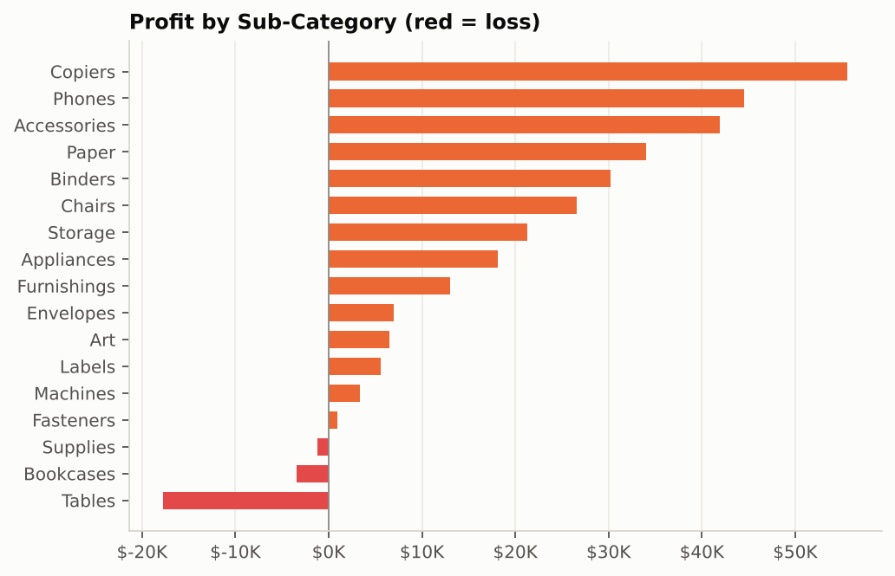
Figure 1 – Profit by sub-category (reference chart from cleaned data)

12.3 Regional and segment performance
Region (manager) | Sales | Profit | Margin | Orders | Avg discount
West (Anna Andreadi) | $725,457.82 | $108,418.45 | 14.94% | 1,611 | 10.9%
East (Chuck Magee) | $678,499.87 | $91,534.84 | 13.49% | 1,401 | 14.5%
Central (Kelly Williams) | $501,239.89 | $39,706.36 | 7.92% | 1,175 | 24.0%
South (Cassandra Brandow) | $391,721.91 | $46,749.43 | 11.93% | 822 | 14.7%

West leads on sales and profit. Central and South are below the average region sales of $574,229.87 (SQL Q12a). Central has the lowest margin, and it also has the highest average discount (24.0% vs 10.9% in the West); Central is the only region where Furniture makes a loss (–$2,871.05). At state level the largest losses are in Texas (–$25,729.36), Ohio (–$16,959.32), Pennsylvania (–$15,559.96) and Illinois (–$12,607.89).
Segment | Customers | Orders | Sales | Profit | Margin | AOV
Consumer | 409 | 2,586 | $1,161,401.35 | $134,119.21 | 11.55% | $449.11
Corporate | 236 | 1,514 | $706,146.37 | $91,979.13 | 13.03% | $466.41
Home Office | 148 | 909 | $429,371.78 | $60,310.74 | 14.05% | $472.36

The Consumer segment generates just over half of all sales (50.56%) but has the lowest margin; Home Office is the smallest segment but has the best margin and order value.

12.4 Trend over time
Year | Sales | YoY growth | Profit | Margin | Orders
2017 | $483,966.13 | — | $49,556.03 | 10.24% | 969
2018 | $470,532.51 | –2.78% | $61,618.60 | 13.10% | 1,038
2019 | $609,205.60 | +29.47% | $81,795.17 | 13.43% | 1,315
2020 | $733,215.26 | +20.36% | $93,439.27 | 12.74% | 1,687

Sales grew 51.5% between 2017 and 2020 and the number of orders rose from 969 to 1,687. Every year shows the same seasonal pattern: January and February are the weakest months and September, November and December the strongest (across all four years, November sales were $352,461 against $59,751 in February). The highest single month was November 2020 ($118,447.82). Month-on-month growth figures are very volatile (for example +1,132% in March 2017 after a very weak February), so yearly and same-month comparisons are more reliable than single month-on-month changes.
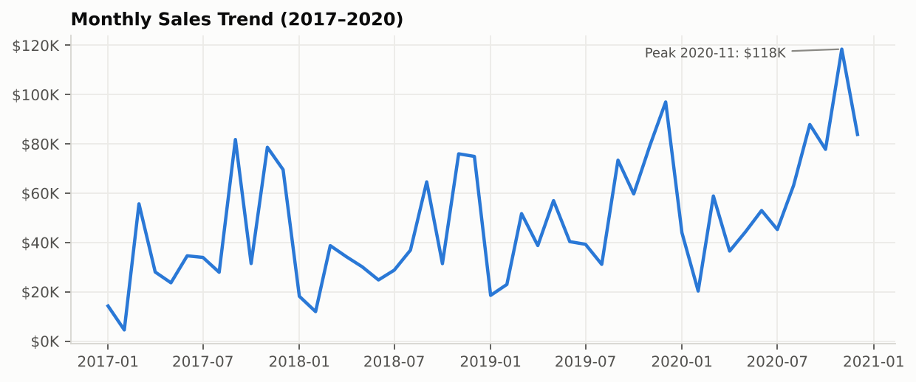
Figure 2 – Monthly sales trend 2017–2020 (reference chart from cleaned data)

12.5 Products
The top 10 products by profit are led by the Canon imageCLASS 2200 Advanced Copier ($25,199.93 profit – more than three times the second product). Six of the top ten are copiers or machines. At the other end, 299 of the 1,849 product names are loss-making overall (and 6 break exactly even). The largest loss is the Cubify CubeX 3D Printer Double Head Print (–$8,879.97, average discount 53%), followed by the Lexmark MX611dhe printer (–$4,589.97) and another Cubify 3D printer (–$3,839.99).

12.6 Discount and profit
Discount band | Order lines | Sales | Profit | Margin | % lines at a loss
No discount (0%) | 4,798 | $1,087,908.47 | $320,987.60 | 29.51% | 0.0%
Low (1–20%) | 3,803 | $846,522.24 | $100,785.47 | 11.91% | 13.8%
Medium (21–40%) | 459 | $233,856.53 | –$35,805.41 | –15.31% | 90.2%
High (>40%) | 933 | $128,632.25 | –$99,558.59 | –77.40% | 100.0%

There is a clear negative association between discount and profitability. Discounted lines are 52% of all lines; all lines at 30% discount or more are loss-making on average, and at 80% discount the margin is –180%. The correlation between discount and line-level profit margin is –0.86 (strong), while the correlation between discount and profit in dollars is –0.22 (weak, because dollar profit also depends on the size of the sale).
Association is not causation. This is observational data – discounts were not assigned at random. Products with high discounts (for example 3D printers, tables, binders) may be low-margin or slow-moving items for other reasons, and regions such as Central may face different competition. The data shows that heavy discounts and losses occur together; it cannot prove that the discount alone caused the loss. A controlled pricing test would be needed to prove cause and effect.
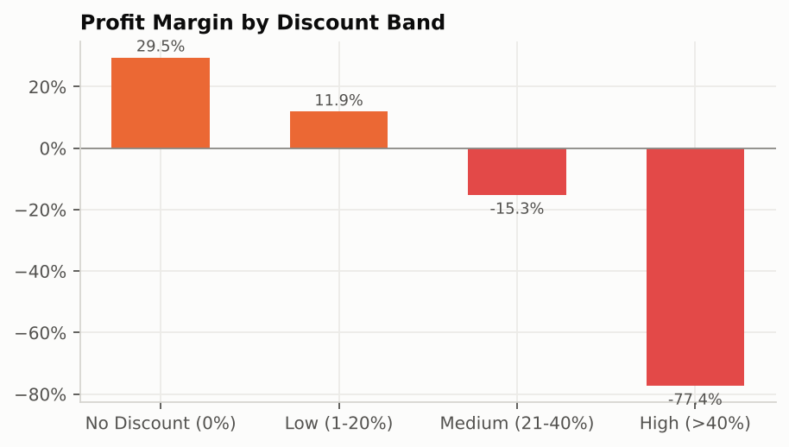
Figure 3 – Profit margin by discount band (reference chart from cleaned data)

12.7 Returns and outliers
296 of 5,009 orders (5.9%) were returned, worth $180,504.28 of sales. The West region's return rate (11.7%) is about four times that of the other regions (about 3%). Sales are highly skewed: the median order line is $54.49 but the largest is $22,638.48 (a Cisco TelePresence system). Such extreme values are real transactions; they were kept, and medians were reported next to averages where relevant.

13. Tableau Visualizations
The following worksheets were built in Tableau from the file 04_Tableau/Superstore_Tableau_Data.xlsx (Orders related to Returns on Order ID and to People on Region). Step-by-step instructions to rebuild them are in Part B, Section B5:
Worksheet | Chart type | Fields | Purpose
KPI – Sales / Profit / Orders / AOV | Text (big number) | SUM(Sales), SUM(Profit), Total Orders, AOV | Headline figures
Monthly Sales Trend | Line | MONTH(Order Date) continuous, SUM(Sales) | Trend and seasonality
Category Performance | Side-by-side bar | Category, Measure Names, Measure Values | Sales vs profit by category
Regional Performance | Side-by-side bar (or filled map by State) | Region, Sales, Profit | Regional comparison
Top 10 Products | Ranked horizontal bar | Product Name, SUM(Profit), Top N set/parameter | Best products
Discount vs Profit | Scatter plot | Discount, Profit (disaggregated), colour = Category | Discount association
Customer Segments | Bar | Segment, SUM(Sales), % of total | Segment contribution

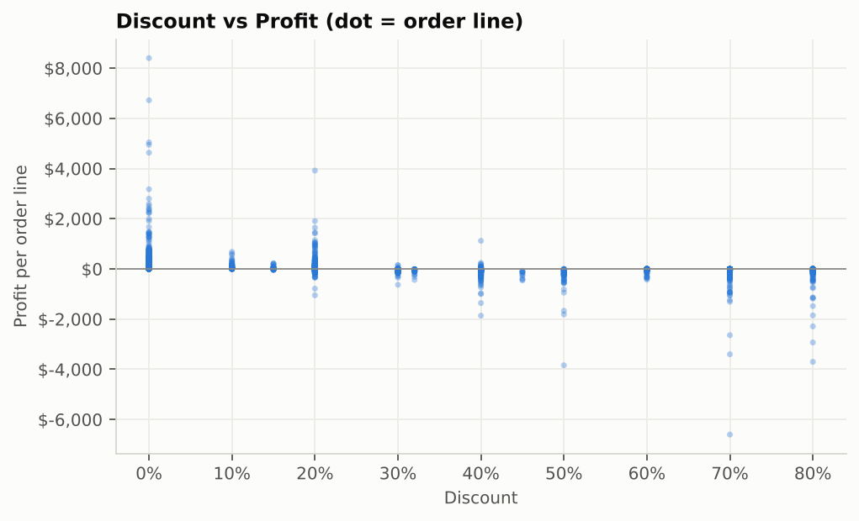
Figure 4 – Discount vs profit, one dot per order line (reference chart from cleaned data)

14. Dashboard Screenshots
Two dashboards were built in Tableau (file 04_Tableau\Retail_Sales_Dashboard.twbx). The main dashboard, "Retail Sales Performance and Profitability Dashboard", has four KPI cards, the monthly sales trend, category and regional sales and profit, and the top 10 products, with Order Date, Region, Category and Segment filters that apply to every worksheet. Region, Category, Segment and Order Date were added to context on the Top 10 sheet so that the top 10 is recalculated inside the filtered data. The screenshots below were exported from Tableau (Dashboard → Export Image).
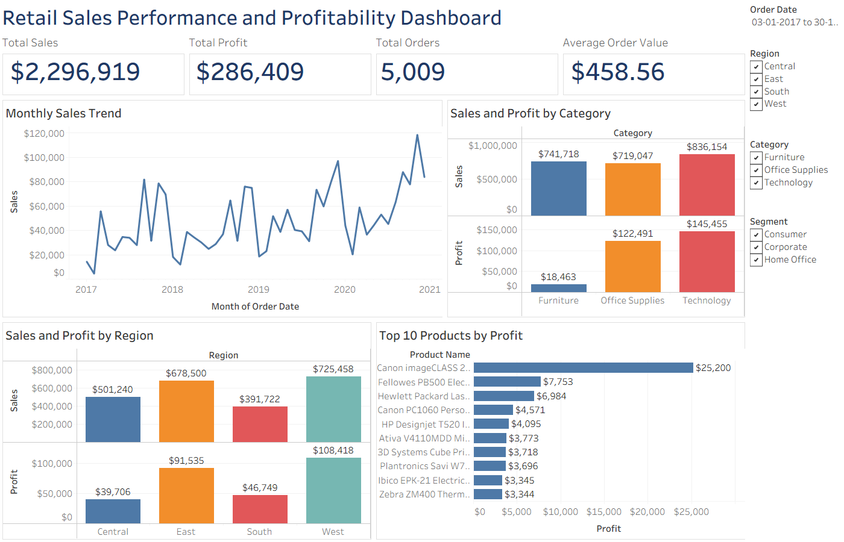
Screenshot 1 – Main dashboard, all data (KPIs match SQL Q1 and Q11)
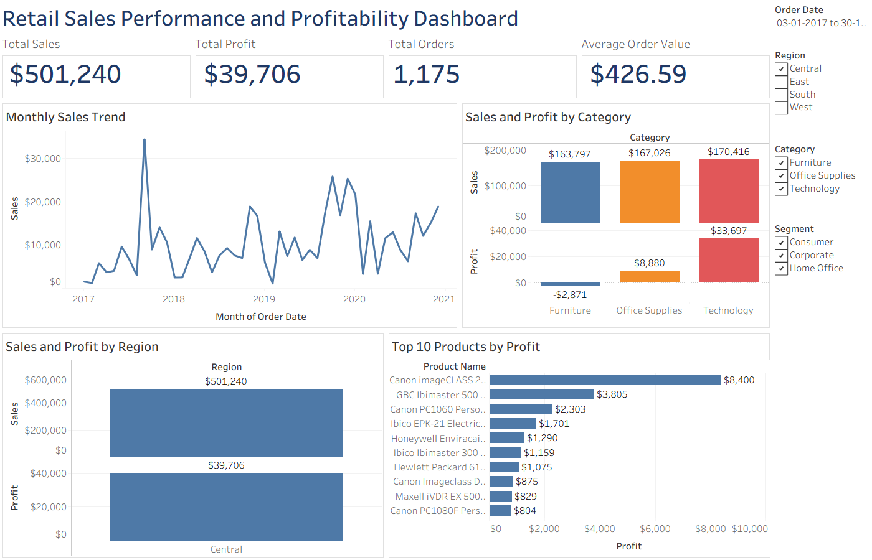
Screenshot 2 – Same dashboard filtered to Region = Central: sales $501,240, profit $39,706, Furniture loss –$2,871, top 10 recalculated
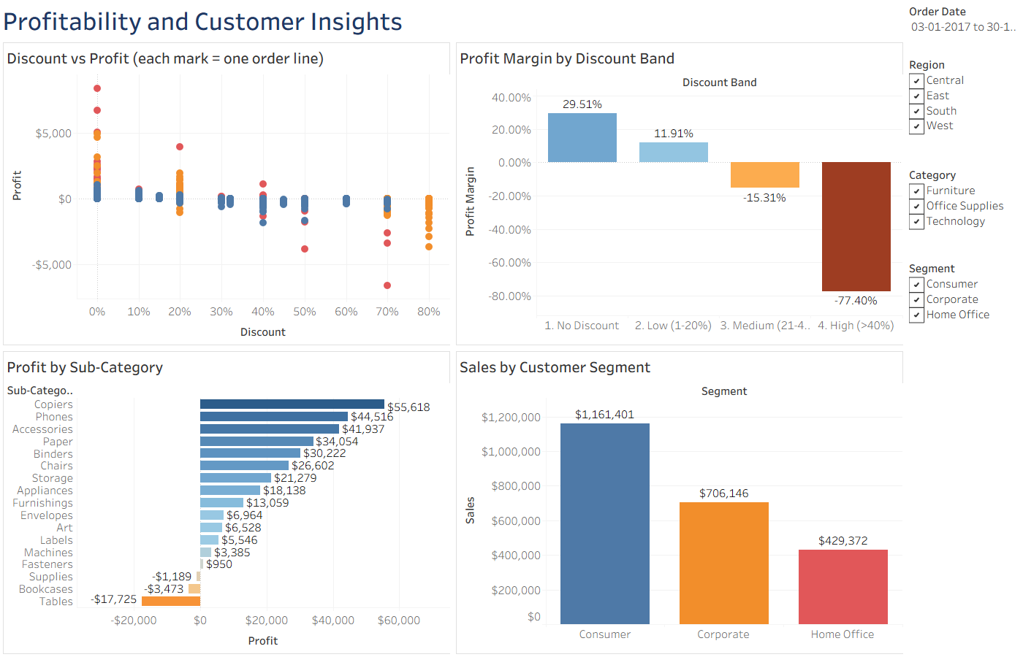
Screenshot 3 – Second dashboard: Profitability and Customer Insights

15. Results and Findings
The findings below are observed facts from the data; the possible explanations are marked as such.
- Overall performance: $2.30 million sales and $286 thousand profit over four years, a 12.47% profit margin, 5,009 orders with an average value of $458.56.
- Growth: sales rose 51.5% from 2017 to 2020 (dip of 2.8% in 2018, then +29.5% and +20.4%).
- Seasonality: every year sales are lowest in January–February and highest in September, November and December.
- Category imbalance: Technology and Office Supplies earn margins of about 17%; Furniture earns 2.49% and contributes only 6.45% of profit despite 32.29% of sales.
- Loss-making sub-categories: Tables, Bookcases and Supplies lose money overall; Machines barely breaks even (1.79% margin) despite high sales.
- Regions: West is strongest (14.94% margin); Central is weakest (7.92%) and has the highest average discount (24%). Texas, Ohio, Pennsylvania and Illinois are the largest loss-making states.
- Segments: Consumer brings 50.6% of sales at the lowest margin; Home Office has the best margin.
- Discounts: margin falls from 29.51% with no discount to –77.40% above 40% discount; every line discounted above 40% made a loss. (Association, not proven cause.)
- Products: profit is concentrated – one copier earns $25,200; 299 product names lose money, led by 3D printers.
- Returns: 5.9% of orders were returned; the West return rate (11.7%) is much higher than elsewhere.

16. Business Recommendations
- Review the discount policy. Require manager approval for discounts above 20% and test a cap (for example 30%). Possible reasoning: discounts above 20% are associated with negative margins in this data. A controlled test in one region is recommended before a company-wide change.
- Fix the Furniture category, starting with Tables and Bookcases. Review pricing, supplier cost and discounting of these sub-categories; consider bundling tables with high-margin items (chairs, furnishings) instead of discounting.
- Re-evaluate loss-making products. Review the 3D printers and the other worst products in Q5b – reprice, renegotiate supply, or stop actively promoting them.
- Focus on the Central region and the loss-making states (Texas, Ohio, Pennsylvania, Illinois): investigate why discounts are higher there and set regional discount targets with the regional manager.
- Plan for seasonality. Increase stock and marketing for September–December; use January–February for clearance of slow stock (with controlled discounts).
- Protect and grow high-margin lines such as Copiers, Phones, Accessories, Paper and Labels – for example by cross-selling them with Furniture orders.
- Investigate West returns. Find out which products and ship modes drive the 11.7% return rate; returns reduce real revenue and cost shipping.
- Segment strategy: keep the large Consumer base but encourage Corporate and Home Office customers, who order more per order at better margins.

17. Limitations
- Sample / fictional dataset: Superstore is a training dataset; results describe this data, not a real company.
- Observational data: associations (e.g. discount vs loss) cannot prove causation; other factors (product mix, region, customer type) are mixed together.
- No cost, marketing or inventory data: profit is given, so we cannot see why a product is unprofitable (price, cost or shipping).
- Returns are flagged only: returned orders are still counted in sales; the dataset does not record refund amounts.
- Data issues that could not be fully resolved: 32 Product IDs have two names; the duplicate row was removed by judgement; the Burlington ZIP code was filled from outside knowledge.
- Time range: four years only; one-off events or price changes are not recorded.
- Tool-specific: INTERSECT/EXCEPT need MySQL 8.0.31+; Tableau Public saves workbooks publicly (acceptable here because the dataset is public).
Future improvements: add cost and marketing data, run a controlled discount experiment, add customer-level analysis (RFM segmentation, repeat-purchase rate), build a sales forecast, and automate the refresh of the database and dashboard.

18. Conclusion
This project took a raw retail dataset through the complete analytics workflow: inspection, cleaning, relational storage, SQL analysis, KPI calculation and dashboard design. Excel showed that only a few genuine data problems existed and that most "strange" values were valid business outcomes. MySQL organised the data into a normalised schema and answered all twelve business questions, with results that match the Excel calculations exactly. The analysis shows a growing business whose profit is concentrated in Technology and Office Supplies, while Furniture, heavy discounts, the Central region and a small set of products erode profit. Tableau turns these findings into an interactive dashboard that managers can filter by date, region, category and segment. The main lesson is that sales growth alone is not success – profitability must be monitored at category, product, region and discount level, and decisions should be tested before being assumed to work.

19. References
- Tableau Software. *Sample – Superstore* dataset (distributed with Tableau Desktop / Tableau Public).
- Packt Publishing. *Mastering Tableau 2021* – companion repository, https://github.com/PacktPublishing/Mastering-Tableau-2021 (Chapter 05, "Sample - Superstore.xls").
- Oracle Corporation. *MySQL 8.0 Reference Manual*, https://dev.mysql.com/doc/refman/8.0/en/
- Microsoft. *Excel functions (alphabetical)* and *Create a PivotTable to analyze worksheet data*, https://support.microsoft.com/excel
- Tableau Software. *Tableau Help – Get Started with Tableau Desktop / Tableau Public*, https://help.tableau.com
- Wexler, S., Shaffer, J. and Cotgreave, A. (2017). *The Big Book of Dashboards*. Wiley.

PART B – IMPLEMENTATION GUIDE (what was done and how to repeat it)

B1. Project folder structure
Everything is inside your folder Desktop\Data analytics project. Keep this structure – the scripts and this guide refer to these names.
Folder / file | What it is
01_Dataset\Sample - Superstore.xls | ORIGINAL dataset – never edit this file
02_Excel\Superstore_Cleaned_Analysis.xlsx | Cleaned workbook: Raw_Orders, Clean_Orders (+14 formula columns), Returns_Clean, People, Data_Quality, Summary_Formulas, Pivot_Tables, Charts, Formula_Guide
03_SQL\01_create_database_and_tables.sql | DDL: database, staging and normalised tables with keys and constraints
03_SQL\02_load_data.sql | DML: INSERTs for 9,993 cleaned lines, 296 returns, 4 managers (one large file)
03_SQL\02a … 02d_load_data_part1-4.sql | The same INSERTs split into 4 smaller files – use these if Workbench's Run SQL Script gives an error
03_SQL\03_populate_normalised_tables.sql | INSERT … SELECT into normalised tables, view vw_sales, indexes
03_SQL\04_business_questions.sql | The 12 business-question queries with expected results
03_SQL\05_sql_concepts_demo.sql | String/date/conversion/conditional functions, joins, subqueries, set operators, TCL, data dictionary, DCL, EXPLAIN
03_SQL\SQL_Query_Results.xlsx | Expected output of every query in file 04 (one sheet per query)
03_SQL\*.csv | Cleaned data as CSV (for LOAD DATA or Workbench import wizard)
04_Tableau\Superstore_Tableau_Data.xlsx | Clean data source for Tableau (Orders, Returns, People)
04_Tableau\Retail_Sales_Dashboard.twbx | Finished Tableau workbook (packaged with its data): 12 worksheets + 2 dashboards
04_Tableau\Retail_Sales_Dashboard.twb | Same workbook, unpackaged (reads Superstore_Tableau_Data.xlsx); base.twb is an empty starter file and can be deleted
05_Report\Project_Documentation.docx | This document
06_Screenshots\Tableau_Dashboard_*.png | Real Tableau dashboard exports used in Section 14
06_Screenshots\fig_*.png, dashboard_reference_mockup.png | Reference charts drawn from the cleaned data (used in Section 12)

B2. Dataset – how it was obtained and inspected
How to get it yourself (any one way):
- Tableau Public/Desktop installs a copy: after installing, look in Documents\My Tableau Repository\Datasources for "Sample - Superstore".
- Kaggle: search "Superstore dataset", download the CSV/XLS (free account needed).
- The exact copy used here: GitHub repository PacktPublishing/Mastering-Tableau-2021 → folder "Chapter 05" → "Sample - Superstore.xls" → Download raw file.
First inspection in Excel (what to show in the viva):
- Open the file → three sheets: Orders, Returns, People.
- Rows: click any cell and press Ctrl + End → last cell is U9995 → 9,994 data rows + 1 header row, 21 columns (A–U). Or type =COUNTA(A:A)-1.
- Data types: select a column and look at the Number format box on the Home tab; check dates with =ISNUMBER(C2) (TRUE means a real date).
- Blanks: select the data → Home → Find & Select → Go To Special → Blanks, or =COUNTBLANK(L2:L9995) per column → only Postal Code has blanks (11).
- Labels: turn on Filter (Ctrl + Shift + L) and open the drop-down of Region, Category, Segment, Ship Mode – each list shows the distinct values, so spelling variants would be visible immediately.
- Ranges: =MIN(R2:R9995), =MAX(...) for Sales, Quantity, Discount, Profit, Order Date.

B3. Excel – step by step

B3.1 Set up the workbook
- Open Sample - Superstore.xls → File → Save As → Excel Workbook (*.xlsx) in 02_Excel.
- Rename the Orders sheet to Raw_Orders. Right-click the tab → Move or Copy → tick "Create a copy" → rename the copy Clean_Orders. All cleaning is done only on Clean_Orders, so the raw data stays available for audit.

B3.2 Cleaning steps (in this order)
- Rename column I1 "Country/Region" → "Country".
- Remove the duplicate line: Data → Remove Duplicates → tick every column except Row ID → OK. Excel reports "1 duplicate value found and removed" (Row ID 3407). Row ID must be excluded because it is unique on every row and would hide the duplicate.
- Postal Code to text: insert a helper column next to Postal Code, type =TEXT(L2,"00000"), double-click the fill handle, copy the helper column, select column L → Paste Special → Values, then delete the helper. 2138 becomes 02138.
- Fill missing Postal Codes: filter Postal Code on (Blanks) → 11 rows, all Burlington, Vermont → type 05401 in the first, copy to the others → clear the filter.
- Formats: select Order Date and Ship Date → Ctrl+1 → Custom → dd-mmm-yyyy. Sales and Profit → Currency, 2 decimals. Discount → Percentage, 0 decimals.
- Standardisation check: filter drop-downs and COUNTIF counts (Data_Quality sheet) show no variants or extra spaces, so no change was needed. If they had existed, the fix would be a helper column =PROPER(TRIM(M2)) pasted back as values.
- Sort: Data → Sort → Order Date (Oldest to Newest), then Add Level → Order ID (A to Z).
- Filter example for the viva: filter Region = Central and Profit → Number Filters → Less Than 0 to show Central's loss-making lines.
- Returns: copy the Returns sheet to Returns_Clean → Data → Remove Duplicates (both columns) → 504 removed, 296 remain.
- People sheet: reorder columns to Region | Manager so VLOOKUP can search the first column.

B3.3 Formula columns added to Clean_Orders (row 2 shown; each is filled down)
Col | Name | Formula | Simple meaning
V | Order_Year | =YEAR(C2) | Year of the order
W | Order_Month | =TEXT(C2,"yyyy-mm") | Year-month text, e.g. 2019-11
X | Ship_Days | =D2-C2 | Days between order and shipping
Y | Customer_Label | =CONCAT(F2," - ",G2) | CG-12520 - Claire Gute
Z | City_State | =CONCATENATE(J2,", ",K2) | Henderson, Kentucky
AA | Profit_Margin | =IFERROR(U2/R2,0) | Line margin; 0 instead of an error
AB | Profit_Status | =IF(U2>0,"Profit",IF(U2<0,"Loss","Break-even")) | Nested IF
AC | Discount_Band | =IF(T2=0,"No Discount",IF(T2<=0.2,"Low (1-20%)",IF(T2<=0.4,"Medium (21-40%)","High (>40%)"))) | Discount groups
AD | High_Sales_Loss | =IF(AND(R2>=500,U2<0),"Yes","No") | Big sale that lost money (259 lines)
AE | Review_Flag | =IF(OR(T2>=0.5,U2<-500),"Review","OK") | Needs review (934 lines)
AF | Price_Type | =IF(NOT(T2=0),"Discounted","Full Price") | NOT reverses the test
AG | Region_Manager | =IFERROR(VLOOKUP(M2,People!$A$2:$B$5,2,FALSE),"Not Assigned") | Manager name from People
AH | Returned | =IF(COUNTIF(Returns_Clean!$A:$A,B2)>0,"Yes","No") | Was the order returned?
AI | Order_Count_Flag | =IF(COUNTIF($B$2:B2,B2)=1,1,0) | 1 on the first line of each order → SUM = distinct orders (5,009)
AJ | Cat_Order_Flag | =IF(COUNTIFS($B$2:B2,B2,$O$2:O2,O2)=1,1,0) | 1 on first line of each order+category → orders containing that category

Why $B$2:B2? The dollar signs freeze the start of the range at row 2 while the end moves down as the formula is copied, so in row 100 the range is B2:B100. COUNTIF therefore counts how many times the Order ID has appeared so far; it equals 1 only on its first appearance.
Why two order flags? One order can contain products from several categories. Counting orders per category with Order_Count_Flag would assign a mixed order only to the category of its first line (Furniture would show 1,102 orders instead of 1,764). Cat_Order_Flag counts each order once per category, so per-category order counts are correct – but they add up to more than 5,009, which is expected.

B3.4 Summary_Formulas sheet
Purpose | Formula (example)
Total Sales | =SUM(Clean_Orders!$R$2:$R$9994)
Total Orders | =SUM(Clean_Orders!$AI$2:$AI$9994)
AOV | =B3/B5 (Total Sales ÷ Total Orders)
Profit margin | =B4/B3 (Total Profit ÷ Total Sales)
Sales of a category | =SUMIF(Clean_Orders!$O$2:$O$9994,A15,Clean_Orders!$R$2:$R$9994)
Lines of a category | =COUNTIF(Clean_Orders!$O$2:$O$9994,A15)
Average line sale | =AVERAGEIF(Clean_Orders!$O$2:$O$9994,A15,Clean_Orders!$R$2:$R$9994)
Orders of a category | =SUMIFS(Clean_Orders!$AJ$2:$AJ$9994,Clean_Orders!$O$2:$O$9994,A15)
Below/above average | =IF(B15<AVERAGE($B$15:$B$17),"Below Avg","Above Avg")
YoY growth | =IFERROR((B50-B49)/B49,"") (2018 vs 2017)

B3.5 Pivot Tables (several on one worksheet)
- Click inside Clean_Orders → Insert → PivotTable → Table/Range = Clean_Orders!$A$1:$AJ$9994 → Existing Worksheet → Location Pivot_Tables!$A$3 → OK.
- Drag Category to Rows; Sales, Profit and Cat_Order_Flag to Values (Sum).
- Click a Sales value → Value Field Settings → Number Format → Currency. Rename "Sum of Cat_Order_Flag" to "Orders".
- For the next pivot click an empty cell to the right with a gap of at least one column (e.g. F3) and repeat with Region; then Segment (K3), Discount_Band (P3), Category + Sub-Category (A13), Order_Year × Category (F13), Region × Category profit (F23). Leaving gaps prevents the "A PivotTable report cannot overlap another" error when pivots grow.
- Grouping dates by month and year: create a pivot with Order Date in Rows → right-click any date → Group → select Months and Years → OK. Add Sales to Values. (Excel 2016+ may group automatically; you can also use the Order_Year and Order_Month columns.)
- % of total: right-click a value → Show Values As → % of Grand Total.
- After changing data: right-click the pivot → Refresh (or Data → Refresh All).
The Pivot_Tables sheet in the delivered workbook was generated automatically (with LibreOffice) and already contains the eight pivots. If your Excel shows a message offering to repair the file, accept it and, if any pivot is missing, rebuild it in two minutes with the steps above – doing it once yourself is also the best viva preparation.

B3.6 Verification before moving on
- Clean_Orders has 9,993 data rows; Total Sales = $2,296,919.49; Total Profit = $286,409.08; Total Orders = 5,009.
- Pivot grand totals equal the Summary_Formulas totals.

B4. MySQL – step by step

B4.1 Install and connect
- Download MySQL Installer for Windows (dev.mysql.com/downloads/installer) → choose "Full" or "Custom" with MySQL Server 8.0 and MySQL Workbench → set a root password and remember it.
- Open MySQL Workbench → click the "Local instance MySQL80" tile → enter the root password.

B4.2 Run the scripts in order
Step | Action | Verify
1 | File → Open SQL Script → 01_create_database_and_tables.sql → Execute (lightning icon) | SHOW TABLES lists 9 tables
2 | Open 02a, 02b, 02c, 02d one after another and execute each (⚡). (The single 02_load_data.sql also works if opened and executed in the editor; Workbench's File → Run SQL Script can fail with "sequence item 6: expected str instance" – a Workbench bug, not a script error.) | After 02d: 9993 | 296 | 4; sales 2296919.4883, profit 286409.0805
3 | Open and execute 03_populate_normalised_tables.sql | regions 4, customers 793, products 1894, orders 5009, order_items 9993, returns 296; vw_sales 9993 rows
4 | Open 04_business_questions.sql; put the cursor inside one query and press Ctrl + Enter | Compare each result with the "Expected" comment and SQL_Query_Results.xlsx
5 | Open 05_sql_concepts_demo.sql and run block by block | Check SELECT VERSION() before INTERSECT/EXCEPT

To save a result for the report: in the result grid click the Export icon → CSV/Excel, or take a screenshot.

B4.3 Why this design (likely viva questions)
- Staging first, then normalise: loading a flat copy is simple and safe; INSERT … SELECT DISTINCT then splits the data. Errors in the split can be fixed without reloading.
- Load order: parent tables (regions, customers, products, orders) before child tables (order_items, returns) because foreign keys reject rows whose parent does not exist yet.
- DECIMAL not FLOAT for money: DECIMAL is exact. While testing, the same queries run with floating-point numbers counted 301–302 loss-making products instead of 299, because six products whose profit sums to exactly 0.0000 came out as tiny negative numbers like –0.00000000001. This is a real example of why money is stored as DECIMAL.
- Surrogate key for products: 32 Product IDs have two different names, so (product_id, product_name) is unique, not product_id alone.
- View vw_sales: gives analysts one simple table while the data stays normalised; a view stores only the query, so it is always current.

B4.4 Line-by-line logic of the 12 business queries
Q | Key clauses | Logic in plain English | Expected result (headline)
1 | SUM, COUNT(*) | Add sales and profit of all 9,993 lines. | $2,296,919.49 / $286,409.08
2 | INNER JOIN products, GROUP BY category, scalar subquery | Attach category to each line, total per category, divide by grand total for %. | Technology $836,154.03 (36.40%)
3 | JOIN orders + regions, GROUP BY region, COUNT(DISTINCT) | Region comes from the order; manager from regions; margin = SUM(profit)/SUM(sales). | West $725,457.82 / $108,418.45
4 | GROUP BY product, ORDER BY profit DESC, LIMIT 5 | Total profit per product, sort high to low, keep 5. | Canon imageCLASS 2200 $25,199.93
5a | GROUP BY sub_category, HAVING SUM(profit) < 0 | HAVING filters groups after aggregation (WHERE cannot use SUM). | Tables, Bookcases, Supplies
5b | HAVING + ORDER BY ASC + LIMIT 10, AVG(discount) | 10 most negative products with their average discount. | Cubify CubeX –$8,879.97
5c | Derived table + COUNT | Count the groups returned by the inner query. | 299
6 | CTE, DATE_FORMAT, LAG() OVER (ORDER BY month) | Total per month; LAG fetches the previous month's value for growth %. | 48 months; peak 2020-11 $118,447.82
6b | YEAR(), GROUP BY | Total per year. | 2020 $733,215.26
7 | JOIN customers, COUNT(DISTINCT), AOV | Segment from the customer table. | Consumer $1,161,401.35
8 | CASE in SELECT, GROUP BY alias | CASE assigns each line a band; aggregate per band. | Margins 29.51% → –77.40%
9 | CTE + RANK() OVER (ORDER BY profit DESC) | Rank products by profit; ties share a rank. | Same top 10 as Tableau
10a | Two scalar subqueries | % of sales vs % of profit per category. | Furniture 32.29% vs 6.45%
10b | CTE + subqueries in WHERE | Sales above average sub-category AND margin below overall margin. | Chairs, Storage, Tables, Machines
11 | COUNT(DISTINCT), ratio of sums | AOV = sales ÷ orders; margin = profit ÷ sales (vs misleading AVG of ratios). | $458.56; 12.47% (vs 12.03%)
12a | HAVING with subquery | Region total below average region total. | South, Central
12b | UNION ALL + CASE + subquery | Region and category margins compared with overall margin in one result. | Furniture, Central, South below

B5. Tableau Public – step by step

B5.1 Install and connect
- Download Tableau Public (public.tableau.com → Create → Download the App), install, sign in with a free account.
- Start page → Connect → Microsoft Excel → 04_Tableau\Superstore_Tableau_Data.xlsx.
- Drag Orders to the canvas. Drag Returns next to it – Tableau creates a relationship (noodle); set it to Order ID = Order ID. Drag People and relate Region = Region. Relationships keep each table at its own level of detail, so returns are not duplicated.
- (Alternative – classic join: double-click Orders to open the physical layer, drag Returns in, choose Left Join on Order ID so non-returned orders are kept.)
- Check data types in the grid: Order Date/Ship Date = Date, Postal Code = String (click the icon to change), Sales/Profit/Discount = Number (decimal).
- Click Sheet 1 to start building.

B5.2 Dimensions and measures
Dimensions (blue, discrete) are categories you slice by – Category, Region, Segment, Product Name, Order Date. Measures (green, continuous) are numbers that are aggregated – Sales, Profit, Quantity, Discount. Blue pills create headers; green pills create axes.

B5.3 Calculated fields (Analysis → Create Calculated Field)
Profit Margin = SUM([Profit]) / SUM([Sales]) (format as %)
Total Orders = COUNTD([Order ID])
Average Order Value = SUM([Sales]) / COUNTD([Order ID])
Discount Band = IF [Discount] = 0 THEN "No Discount"
ELSEIF [Discount] <= 0.2 THEN "Low (1-20%)"
ELSEIF [Discount] <= 0.4 THEN "Medium (21-40%)"
ELSE "High (>40%)" END
Profit Status = IF SUM([Profit]) < 0 THEN "Loss" ELSE "Profit" END
Is Returned = IF ISNULL([Returned]) THEN "No" ELSE "Yes" END
Profit Rank = RANK(SUM([Profit])) (table calculation)
Running Total Sales = RUNNING_SUM(SUM([Sales])) (table calculation)
Sales Growth % = (SUM([Sales]) - LOOKUP(SUM([Sales]), -1))
/ ABS(LOOKUP(SUM([Sales]), -1))
Profit Margin must be written as SUM/SUM (aggregate ratio), not [Profit]/[Sales] – the latter would be averaged row by row and give the misleading 12.03%.

B5.4 Groups, sets and parameter
- Group: right-click Ship Mode → Create → Group → select First Class + Same Day → Group → name "Fast Shipping"; the rest → "Standard Shipping".
- Parameter: right-click in Data pane → Create Parameter → Name "Top N", Integer, Range 5 to 20, step 5, current 10 → right-click it → Show Parameter.
- Set: right-click Product Name → Create → Set → name "Top N Products" → Top tab → By field → Top Top N by Profit, Sum. The set updates when the parameter changes.
- Condition set: right-click Sub-Category → Create → Set → "Loss Sub-Categories" → Condition tab → By formula SUM([Profit]) < 0.

B5.5 Worksheets
Sheet name | How to build it
KPI Sales | Drag Sales to Text on the Marks card. Format → Numbers → Currency (custom), 0 decimals. Click Text → edit to "Total Sales" on line 1 and <SUM(Sales)> on line 2 (larger font). Repeat for KPI Profit (Profit), KPI Orders (Total Orders), KPI AOV (Average Order Value).
Monthly Sales Trend | Drag Order Date to Columns → right-click the pill → choose the green Month (May 2015) (continuous). Drag Sales to Rows. Marks = Line. Optional: drag Profit Margin to Tooltip.
Category Performance | Category to Columns; Measure Values to Rows; filter Measure Names to only Sales and Profit; Measure Names to Columns (after Category) and to Color. Click Label → Show mark labels.
Regional Performance | Same as Category with Region. Map alternative: double-click State (map appears), drag Profit to Color (diverging red–blue), Sales to Tooltip.
Top 10 Products | Product Name to Rows, Profit to Columns, sort descending (toolbar). Drag the Top N Products set to Filters (In). Labels on. Add Profit Rank to Rows before Product Name (change to Discrete) to show the rank number.
Discount vs Profit | Analysis menu → untick Aggregate Measures. Discount to Columns, Profit to Rows, Category to Color, Product Name to Tooltip. Analytics pane → drag Trend Line onto the view.
Customer Segments | Segment to Columns, Sales to Rows, labels on; right-click SUM(Sales) on Label → Quick Table Calculation → Percent of Total.
Discount Band Margin (dashboard 2) | Discount Band to Columns, Profit Margin to Rows, Profit Status to Color.

Sorting, labels, totals and subtotals: use the sort buttons on the toolbar; Label button on the Marks card; Analysis → Totals → Show Column Grand Totals / Add All Subtotals (try it on a Category × Sub-Category crosstab).
Running total and rank: right-click a measure pill → Quick Table Calculation → Running Total or Rank.

B5.6 Filter types (know the order of operations)
Filter | What it does | Example
Extract filter | Limits the rows saved in the extract | Keep only Country = United States
Data source filter | Applies to every sheet using the data source | Exclude test data
Context filter | Applied first; Top N and FIXED calculations are computed inside it | Region in context → Top 10 products within the selected region
Dimension filter | Filters categorical values | Category = Furniture
Measure filter | Filters on an aggregated number | SUM(Sales) > 10,000
Table calculation filter | Hides marks after table calculations | Profit Rank ≤ 10

B5.7 Build the dashboard
- Click the New Dashboard icon. Size (left pane) → Fixed size → 1400 × 900 (or Automatic).
- Drag a Vertical container onto the canvas. Inside it, drag a Text object → type "Retail Sales Performance and Profitability Dashboard" (bold, 20 pt).
- Drag a Horizontal container below the title and drop the four KPI sheets into it side by side → select the container → Distribute Contents Evenly.
- Below it add another Horizontal container with Monthly Sales Trend (wider) and Category Performance; then a third with Regional Performance and Top 10 Products.
- Filters: click the Monthly Sales Trend sheet on the dashboard → small arrow → Filters → Order Date (choose "Range of dates"), Region, Category, Segment. For each filter card: arrow → Apply to Worksheets → All Using This Data Source. Now every chart responds.
- Make the Top 10 respect the filters: on the Top 10 Products sheet right-click the Region, Category, Segment and Order Date filters → Add to Context (otherwise the top 10 is computed on all data first).
- Interactivity: select the Category chart → click the funnel icon Use as Filter, so clicking a category bar filters the other charts.
- Formatting: Format → Dashboard → title font; use the same blue for Sales and orange for Profit everywhere; remove gridlines (Format → Lines); edit tooltips (Marks → Tooltip) e.g. "<Category>: Sales <SUM(Sales)>, Profit <SUM(Profit)>, Margin <AGG(Profit Margin)>".
- Check: with no filters, the KPI cards must read $2,296,919 / $286,409 / 5,009 / $458.56. Select Region = Central → sales $501,240, profit $39,706.
- Optional Dashboard 2 – Profitability & Customer Insights: Discount vs Profit scatter, Discount Band Margin, Profit by Sub-Category (Loss Sub-Categories set in colour), Customer Segments, return rate by Region.
- Save: File → Save to Tableau Public (requires sign-in; the workbook becomes public, which is fine for this public dataset). Also File → Save As a .twbx into 04_Tableau if your version allows, and Dashboard → Export Image into 06_Screenshots.

B6. Final verification checklist
Check | Expected value | Where
Clean rows | 9,993 | Excel Data_Quality, MySQL order_items, Tableau COUNT(Orders)
Total sales | $2,296,919.49 | Excel KPI, SQL Q1, Tableau KPI
Total profit | $286,409.08 | same
Distinct orders | 5,009 | Excel SUM(Order_Count_Flag), SQL COUNT(DISTINCT), Tableau COUNTD
AOV | $458.56 | Excel, SQL Q11, Tableau
Profit margin | 12.47% | Excel, SQL Q11, Tableau
Furniture margin | 2.49% | Excel, SQL Q10a, Tableau tooltip

PART C – VIVA PREPARATION

C1. Likely viva questions with answers

Data analytics fundamentals
Q1. What is data analytics, and which types did you use?
Data analytics is examining data to find information that supports decisions. There are four types: descriptive (what happened), diagnostic (why it happened), predictive (what will happen) and prescriptive (what to do). This project is descriptive and diagnostic – no prediction or machine learning.
Q2. Why did you choose the Superstore dataset?
It has every field needed for the business questions – dates, products, categories, regions, segments, sales, quantity, discount and profit – plus Returns and People sheets for joins. It is clean enough for a mini project but still has real quality issues to fix, and it is the standard dataset used in Tableau learning.
Q3. What does one row of the dataset represent?
One product line inside one order. That is why there are 9,993 rows but only 5,009 orders – an order with three products has three rows. So orders must be counted with COUNT(DISTINCT Order ID), not COUNT(*).

Data cleaning
Q4. What data-quality problems did you find?
Eleven blank postal codes (all Burlington, Vermont), 438 postal codes that had lost their leading zero because they were stored as numbers, one exact duplicate order line, 504 repeated rows in the Returns sheet, and 32 Product IDs with two different names. There were no spelling variants, extra spaces or invalid numbers.
Q5. Why did you not delete rows with negative profit?
Negative profit is a valid business value – it means the company lost money on that line. It is exactly what we want to analyse. Deleting it would make the business look more profitable than it is. We only fix values that are wrong or missing.
Q6. How did you handle the duplicate row, and why exclude Row ID?
I used Data → Remove Duplicates with every column except Row ID. Row ID is unique for every row, so including it would make every row look different. Rows 3406 and 3407 were identical in all other fields; I kept 3406 and removed 3407 and documented the decision. Its effect is only $281 of sales.
Q7. Why store postal code as text?
A postal code is an identifier, not a quantity – we never add or average it. Stored as a number, 02138 becomes 2138. As text it keeps its leading zero, and SQL uses CHAR(5).

Excel formulas
Q8. Difference between SUMIF and SUMIFS?
SUMIF has one condition: SUMIF(range, criteria, sum_range). SUMIFS can take many conditions and the sum range comes first: SUMIFS(sum_range, range1, criteria1, range2, criteria2…). Example: SUMIF on Category gives Technology sales of $836,154.
Q9. Explain your nested IF for the discount band.
=IF(T2=0,"No Discount",IF(T2<=0.2,"Low (1-20%)",IF(T2<=0.4,"Medium (21-40%)","High (>40%)"))). Excel checks the first condition; if it is false it moves to the next IF. Order matters – we test the smallest value first so each discount falls in exactly one band.
Q10. What do AND, OR and NOT do in your workbook?
AND is true only if all conditions are true (High_Sales_Loss: sales ≥ 500 AND profit < 0 – 259 lines). OR is true if any condition is true (Review_Flag: discount ≥ 50% OR loss over $500 – 934 lines). NOT reverses a result (Price_Type: NOT discount = 0 → "Discounted").
Q11. Why IFERROR?
It replaces an error with a value I choose. Profit/Sales would give #DIV/0! if sales were zero; IFERROR shows 0 instead. With VLOOKUP it shows "Not Assigned" if a region is not found.
Q12. How did you count distinct orders in Excel?
With an expanding COUNTIF: =IF(COUNTIF($B$2:B2,B2)=1,1,0). The range starts fixed at B2 and grows as the formula is copied, so it returns 1 only the first time an Order ID appears. Summing the column gives 5,009 orders.

Pivot Tables
Q13. What is a Pivot Table and why use one?
It is an interactive summary that groups and aggregates data by dragging fields into Rows, Columns, Values and Filters, without writing formulas. It is fast for exploring and checking results, e.g. sales by category or by year and month.
Q14. How do you group dates by month and year in a Pivot Table?
Put Order Date in Rows, right-click a date, choose Group, select Months and Years. Excel then shows years with months under them.

SQL
Q15. Difference between WHERE and HAVING?
WHERE filters individual rows before grouping; HAVING filters groups after aggregation, so it can use SUM, COUNT, etc. Example: HAVING SUM(profit) < 0 finds loss-making sub-categories (Tables, Bookcases, Supplies).
Q16. Explain your database design and keys.
Six normalised tables: regions, customers, products, orders, order_items and returns. Each has a primary key; orders references customers and regions; order_items references orders and products; returns references orders. This avoids storing the same customer or product details on thousands of rows.
Q17. Why does products use a surrogate key?
In the source data 32 Product IDs appear with two different names, so product_id is not unique. I used an AUTO_INCREMENT product_key as primary key and a UNIQUE constraint on (product_id, product_name), so no information is lost.
Q18. Difference between INNER JOIN and LEFT JOIN with an example from your project.
INNER JOIN returns only matching rows – orders joined to returns gives the 296 returned orders. LEFT JOIN returns all rows from the left table and NULLs where there is no match – orders LEFT JOIN returns WHERE returns.order_id IS NULL gives the 4,713 orders that were not returned.
Q19. What is a subquery? Give an example.
A query inside another query. In Q12a, HAVING SUM(sales) < (SELECT SUM(sales)/COUNT(DISTINCT region) FROM vw_sales) compares each region with the average region total of $574,230, returning South and Central.
Q20. What are DDL, DML, DCL and TCL?
DDL defines structure (CREATE, ALTER, DROP). DML works with data (INSERT, UPDATE, DELETE, SELECT). DCL controls access (GRANT, REVOKE). TCL controls transactions (COMMIT, ROLLBACK). In file 05 I insert, update and delete inside a transaction and then ROLLBACK so the data is unchanged.
Q21. How did you calculate month-on-month growth in SQL?
A CTE totals sales per month using DATE_FORMAT(order_date, '%Y-%m'). The window function LAG(sales) OVER (ORDER BY order_month) returns the previous month's sales, so growth = (sales – previous) / previous × 100.
Q22. Why DECIMAL instead of FLOAT?
DECIMAL stores exact values, FLOAT stores approximations. When the queries were tested with floating-point numbers, six products whose profit totals exactly zero appeared slightly negative, so the count of loss-making products became 301–302 instead of 299. Money must be exact.
Q23. What is the data dictionary in MySQL?
INFORMATION_SCHEMA – read-only views describing the database itself: TABLES, COLUMNS, TABLE_CONSTRAINTS, KEY_COLUMN_USAGE (foreign keys), STATISTICS (indexes), VIEWS. I query them in section I of file 05.
Q24. How would you handle a much larger dataset?
Index columns used in joins and filters, check plans with EXPLAIN, select only needed columns, bulk-load with LOAD DATA INFILE in transactions, use correct data types, and pre-aggregate summary tables or extracts for dashboards.

KPIs
Q25. How did you calculate profit margin, and why not average the row margins?
Overall margin = total profit ÷ total sales × 100 = 12.47%. Averaging each row's margin gives 12.03% and is wrong because a $2 sale counts as much as a $20,000 sale.
Q26. What is Average Order Value and what is it in your data?
Total sales divided by number of distinct orders: $2,296,919.49 ÷ 5,009 = $458.56. Dividing by the 9,993 lines would give average line value, not order value.

Tableau
Q27. Difference between dimensions and measures?
Dimensions are qualitative fields used to group and slice (Category, Region, Order Date); measures are numeric fields that are aggregated (Sales, Profit). Discrete (blue) fields create headers; continuous (green) fields create axes.
Q28. Which calculated fields did you create?
Profit Margin = SUM([Profit])/SUM([Sales]), Total Orders = COUNTD([Order ID]), AOV = SUM([Sales])/COUNTD([Order ID]), Discount Band (IF/ELSEIF), Profit Status, Is Returned, plus table calculations RANK, RUNNING_SUM and growth with LOOKUP.
Q29. What is the difference between a group and a set?
A group combines dimension members into higher-level categories (First Class + Same Day = "Fast Shipping"). A set is a subset defined by a condition or top-N rule that is In or Out (Top N Products by profit), and it can change dynamically with a parameter.
Q30. What is a context filter and why did you use it?
A context filter is applied before other filters, Top N sets and FIXED calculations. Without it, Top 10 Products is calculated on all data and then the region filter removes products, leaving fewer than 10. Adding Region/Category/Segment/Date to context makes the top 10 correct for the selection.
Q31. How did you make the filters work on the whole dashboard?
For each filter card: Apply to Worksheets → All Using This Data Source. I also used the Category chart as a filter (Use as Filter) for click interaction.

Business insights
Q32. What is your most important finding?
Sales are balanced across categories but profit is not: Furniture is 32% of sales but only 6% of profit (2.49% margin), and discounts above 20% are associated with losses – every line discounted above 40% lost money.
Q33. Can you say discounts cause losses?
No. The data is observational – discounts were not given at random. High discounts are concentrated in certain products (3D printers, tables) and regions (Central), which may be unprofitable for other reasons. I can say they are strongly associated (correlation –0.86 with line margin); proving cause would need a controlled pricing test.

Limitations & future
Q34. What are the limitations and how would you improve the project?
The dataset is a training sample, has no cost or marketing data, returns have no refund amounts, and the analysis is observational. I would add cost data, run a controlled discount experiment, add customer RFM analysis and repeat-purchase rate, build a sales forecast and automate the data refresh.

Methodology
Q35. Why use three tools instead of one?
Each has a role: Excel is best for quick inspection, cleaning and ad-hoc checks; MySQL stores data reliably with integrity rules and answers questions with repeatable queries; Tableau presents results interactively to non-technical users. Using all three also let me cross-check that every tool gives the same totals.

C2. Two-minute project explanation (presentation script)
Speak slowly – about 260 words fits two minutes. Point at the dashboard while you speak.
"Good morning. My project is Retail Sales Performance and Profitability Analysis using Excel, SQL and Tableau.
The problem is that a retail company sees its sales growing, but it does not clearly know where it earns profit and where it loses it. I used the Tableau Superstore dataset – about ten thousand order lines from a US office-supplies retailer between 2017 and 2020.
First, in Excel, I inspected the data and fixed only genuine problems: eleven missing postal codes, postal codes that had lost their leading zeros, one duplicate line and repeated return records. I kept negative profits because a loss is a real business result. I added formula columns with IF, AND, OR, VLOOKUP and COUNTIF, and built summaries with SUMIF and Pivot Tables.
Second, in MySQL, I designed a normalised database with six tables, primary and foreign keys, and wrote SQL queries with joins, subqueries, CASE and window functions to answer twelve business questions.
Third, in Tableau, I built an interactive dashboard with KPI cards, a monthly trend, category and regional comparisons and the top ten products, with filters for date, region, category and segment.
The results: total sales of 2.3 million dollars, profit of 286 thousand, a 12.5 percent margin and an average order value of 459 dollars. Sales grew 51 percent over four years with a strong year-end peak. Technology and Office Supplies earn about 17 percent margin, but Furniture earns only 2.5 percent, and Tables lose money. Discounts above 20 percent are strongly associated with losses – though, since this is observational data, that is an association, not proof of cause.
I recommend controlling high discounts, reviewing Furniture pricing, focusing on the Central region, and planning stock for the year-end season. Thank you."

C3. Numbers to remember
Item | Value
Rows raw / clean | 9,994 / 9,993
Orders / customers / products (IDs) | 5,009 / 793 / 1,862
Total sales / profit | $2,296,919.49 / $286,409.08
Margin / AOV | 12.47% / $458.56
Best category / worst margin | Technology $836K (17.40%) / Furniture 2.49%
Best / weakest region | West $725K, 14.94% / Central 7.92% (South lowest sales)
Loss sub-categories | Tables –$17.7K, Bookcases –$3.5K, Supplies –$1.2K
Top product | Canon imageCLASS 2200 Advanced Copier, $25,199.93 profit
Worst product | Cubify CubeX 3D Printer Double Head Print, –$8,879.97
Discount bands margin | 0%: 29.51% · 1–20%: 11.91% · 21–40%: –15.31% · >40%: –77.40%
Growth 2017→2020 | +51.5% (peak month Nov 2020, $118,448)
Returns | 296 orders (5.9%); West 11.7%

